***Internet Programming Project***

***CSE_341***

Team Members :-

|  |  |
| --- | --- |
| Name | ID |
| Mostafa Essam Mohamed Bayomy | 18P9203 |
| Noureldin Khaled | 18P5722 |

Project Description :-

Our Project is a demo of a book store where you can browse through books , see their details(author, category, .. etc) then decide if you want to add them to your cart and buy them .

You can browse between the “home page“ and the “About“ page at any time, and you can also log in as a user .

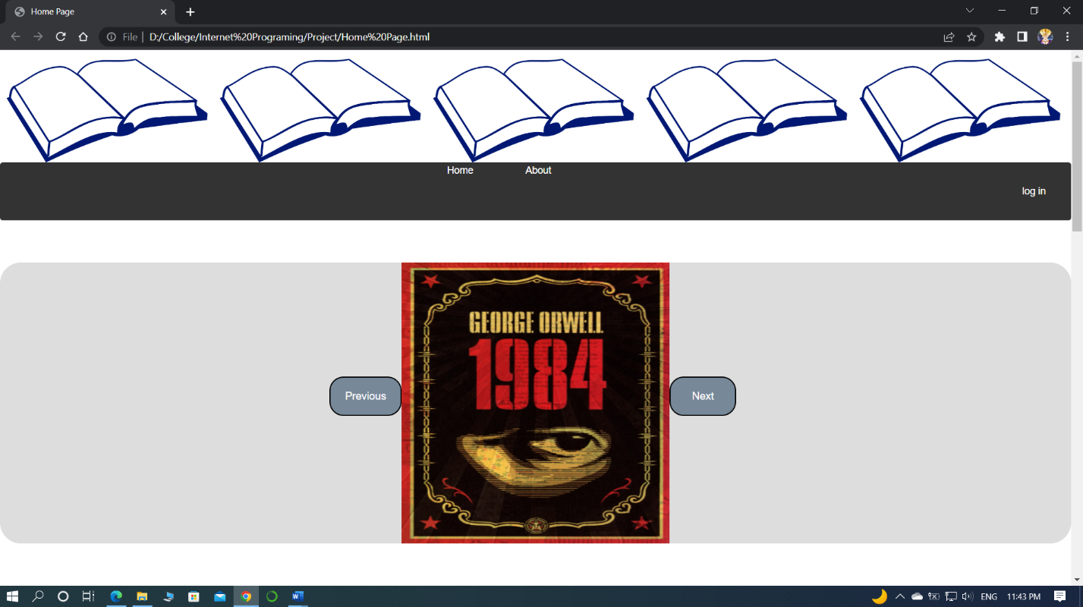Home Page:

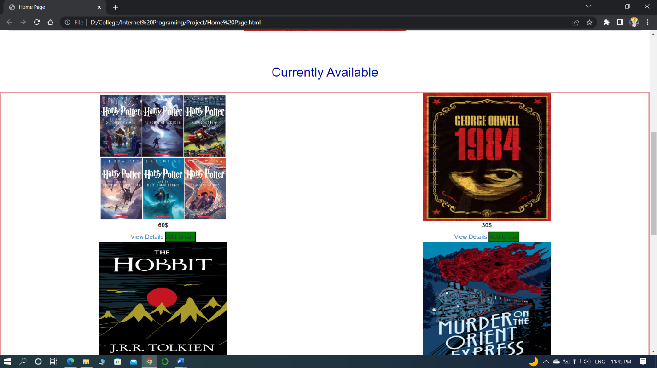

Log in :

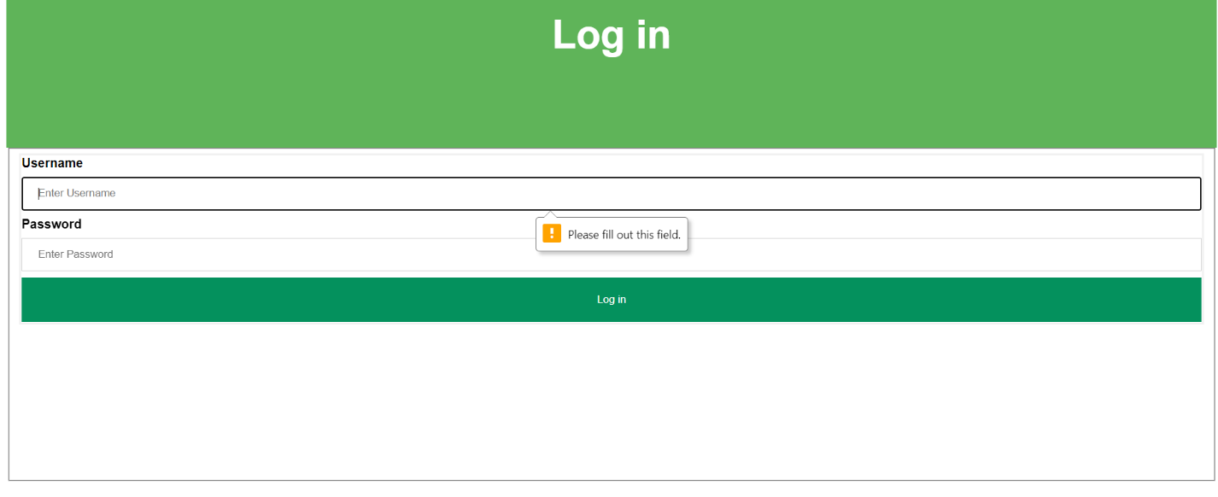If you attemp to log in while the either of the two fields are empty you will get an alert.

User Page :

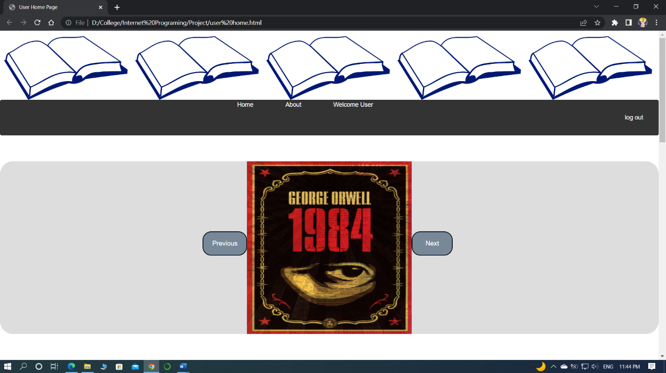

Book Details:

